**SUBMITTED BY:**

1. **MUHAMMAD MUJTABA (SP22-BSE-036)**
2. **MALAIKA WAHID (SP22-BSE-025)**
3. **AYESHA MAJEED (SP22-BSE-008)**

**SUBMITTED TO:**

**SIR ATTIQUE ZAFAR**

SOFTWARE ENGINEERING CONCEPT

ASSIGNMENT # 3

December 11, 2022

**CLASS DIAGRAM:**

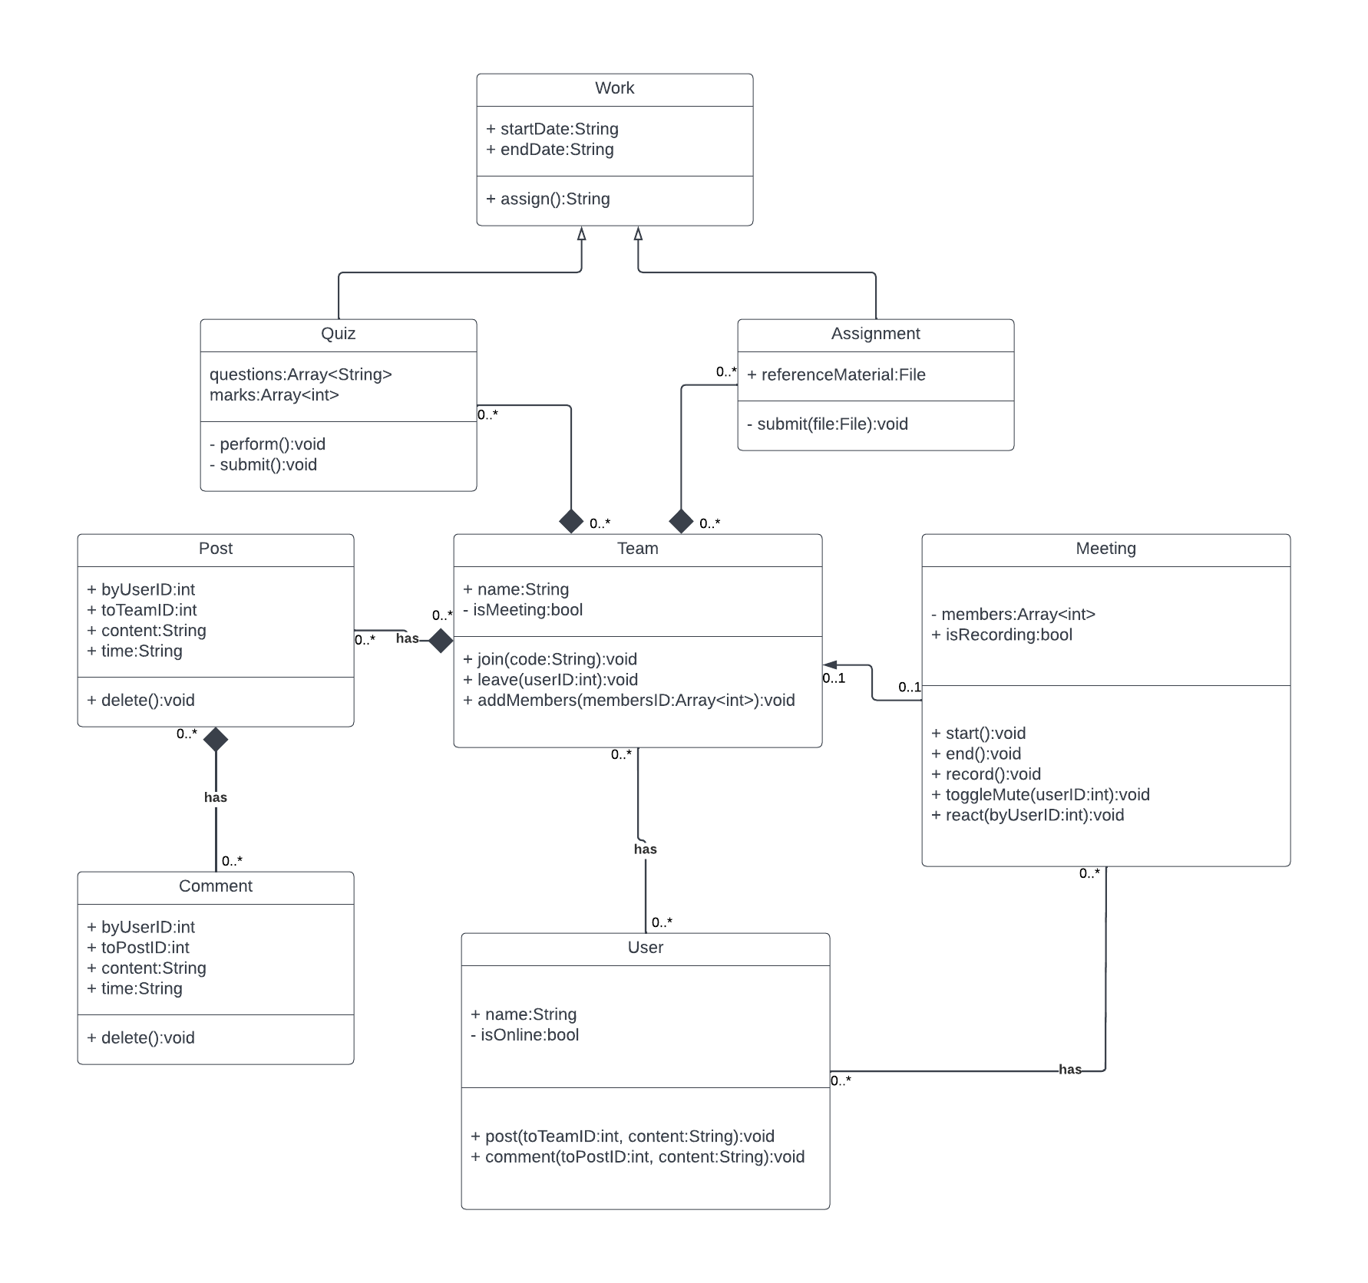

**SEQUENCE DIAGRAMS:**

1. **JOIN TEAMS**

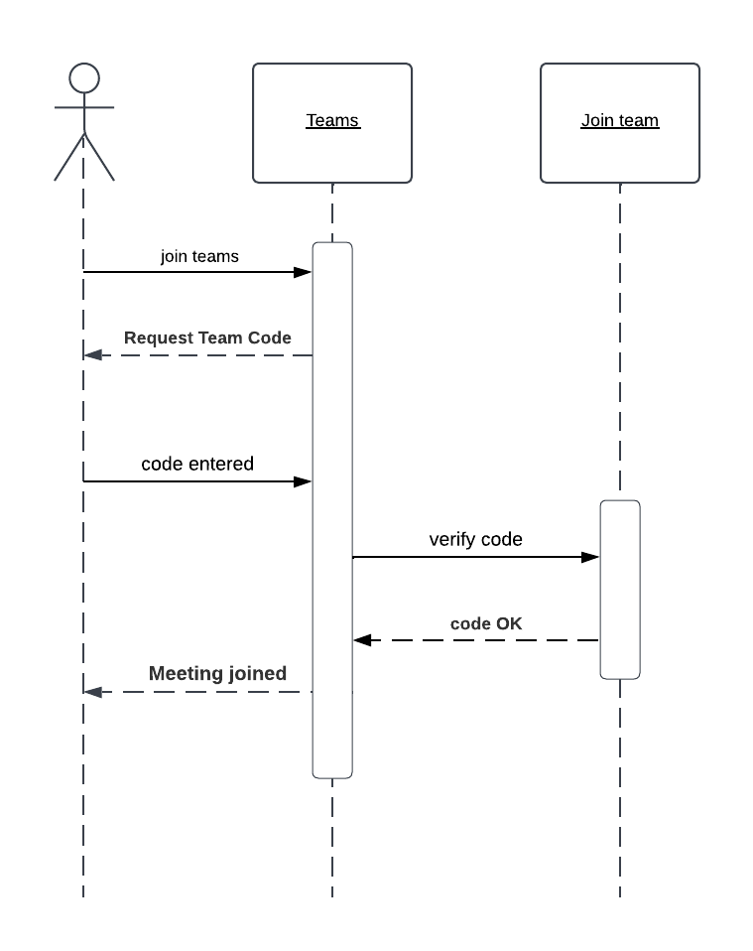

**2) VIEW GRADES**

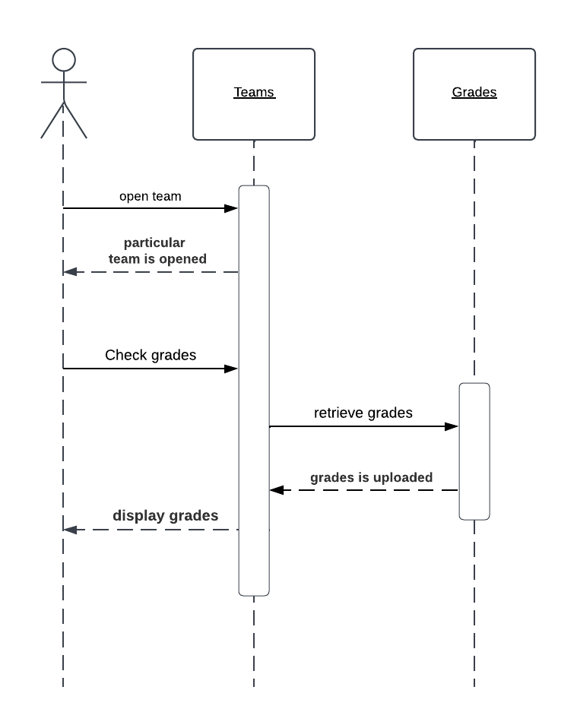

**3) VIEW QUIZ**

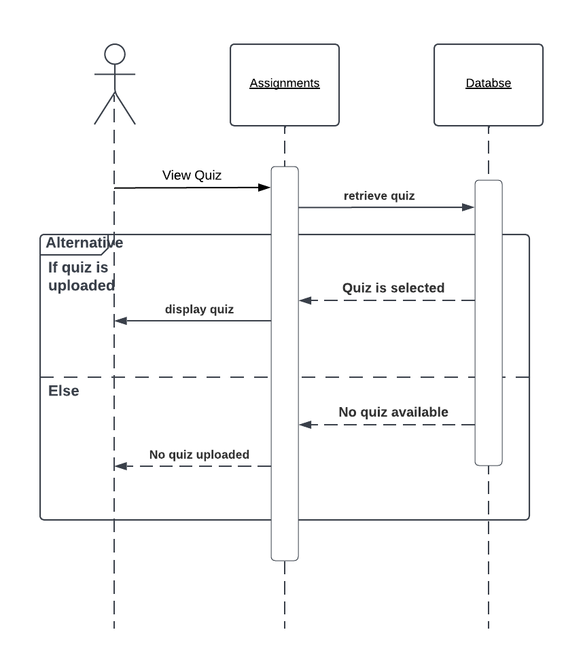

**4) UPLOAD FILE**

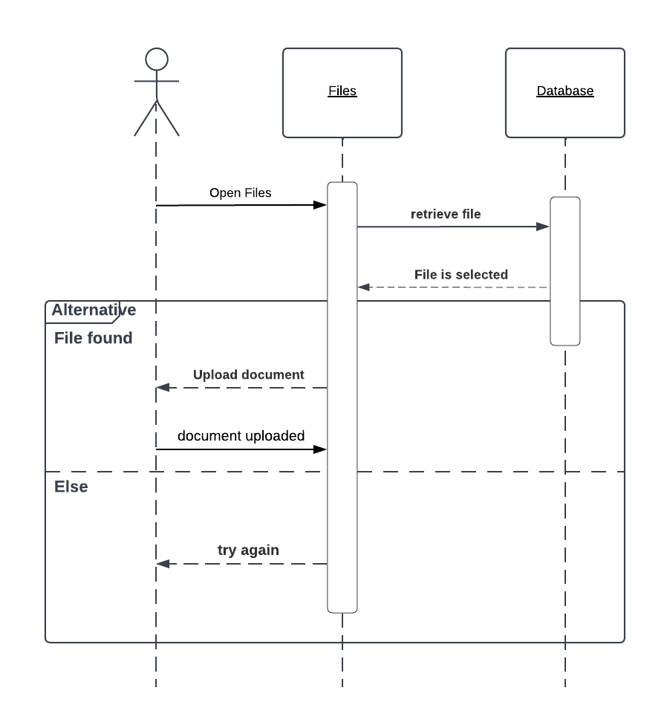

**5) UPLOAD ASSIGNMENT**

